University of Oregon
Department of Landscape Architecture
Winter 2018 Course Description:
LA 489/589 Landscape Architecture Tech Studio
MWF 1:00- 4:50 PM • Location TBA • 6 credits • Grading P/NP
Stangeland/Robertson

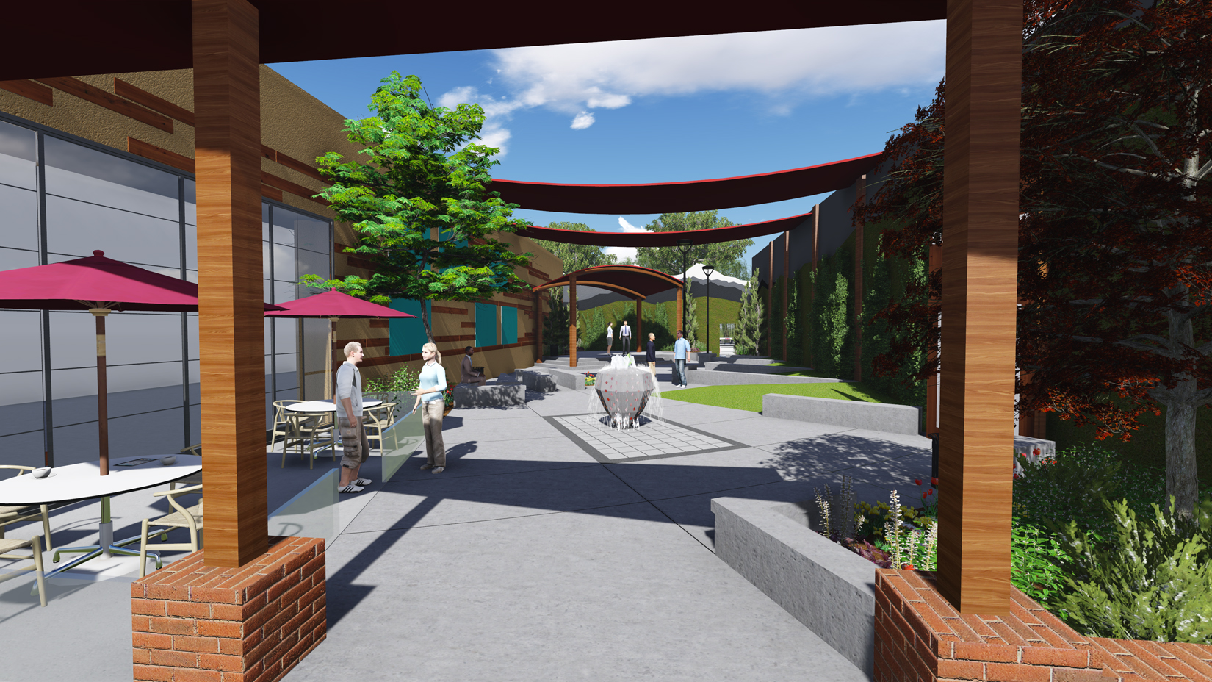

The unique focus of this class is centered on the professional preparation of contractual documents. The engagement of this work simultaneously addresses the programmatic expectations of our client, a profound and meaningful response to the environment, public safety, accessibility, and financial affordability. The results of this class will be a compilation of 3D models, materials specifications, calculations, rendered drawings, and construction documents.

The emphasis in this class will be on the integration of your technical and design skills. This studio offers the opportunity to demonstrate your capacity to see the construction of landscapes as a complex ensemble of structural elements, plant materials, theoretical insights, ecological systems, historical influences, etc. We are immensely interested in the physicality of your project and how we can shape your dreams into reality.

Our goal is a set of construction drawings for a new urban plaza located in the Willamette Valley.This new plaza must support an expanded program of elements and will incorporate design solutions that follow best management practices. The design will need to address urban plaza needs, universal accessibility, bicycle parking, lighting and storm water best management practices. The final construction drawing set will require you to prepare several different plan drawings including but not limited to: site plan, grading plan, dimensioning plan, lighting plan, and planting plan. Sections, elevations, and details, sufficient to bid and construct your design, will also be included in your submission.
The term will commence with a series of site visits to plazas and courtyards around the campus area which will focus on strategies for grading, materiality and construction dimensioning. The first Saturday of the term January 13th, students will take an all day field around Eugene. THIS FIELD TRIP IS REQUIRED. We will review the programmatic intentions for the new plaza. During the field trip around Eugene we will visit a number of landscapes in and around the University of Oregon campus, finishing the field trip with a seminar on outdoor lighting. The students will be required to photograph, sketch, measure key plaza features i.e., paving material, drainage systems, bollard, lighting and all other materials to be used in the final design. The goal is to use these sketches and conversations to prepare us for the work that will be required in the preparation of your construction drawings.

The first two weeks will focus on defining what landscape construction drawings are, where they fit into the design process and how they are part of the larger construction package. Through a series of lectures, readings, and assignments, students will practice drawing layout plans, grading plans and the detailing of key elements for the plaza. In addition to this work, we will use current CAD base drawings to study design options in plan view, 3D models, and section/elevations to assist in our thinking about these structures and landscape elements.

Work sessions on grading, dimensioning, detailing, planting design, lighting and paving design will be held weekly. Students will use their plaza to study each one of these facets of design development and construction drawings.

Our mid term review will include both client and invited professional reviews of your detailed designs for the plaza. The mid term review will include design development plans, 60% complete set of construction drawings, sketch up model, materials board, furniture and lighting selections, and an illustrative poster showing imagery of the project. The review will focus on critiquing the 60 % completion set of construction drawings.

The remainder of the studio will focus on construction drawing set process and the preparation of the final construction drawings. You will now be able to refine details, construction drawings, printing a draft set, redline and adjust your drawings.

Class Prerequisites
All students are required to have completed and received a passing grade in all prerequisite classes prior to taking the Tech Studio. These include, but are not limited to: All previous studio classes (LA 289/589, LA 439/539), Tech I (LA 363) and Tech II (LA 366). Students who do not meet these criteria will not be allowed to take this studio.

Grading Policy
The class is a Pass/No Pass class. At mid term students will be informed whether the work and attendance is deserving of a pass. Attendance, turning in the assignments on time, and completing all of the assignments is a must. This will account for 65% of the grading policy. The students will be allowed two excused absences. Students needing to take an incomplete will need to get approval from and advisor and professor. Students who opt to take an incomplete will be required to use the course work from the term, and will still be expected to complete the design set. Students working in the computer lab must attend class at the beginning and end of each studio.

Objectives
Upon completion of the class students should have a firm knowledge of the technical systems, conventions and practices employed during the translation of a schematic design into a professional - contractual style - construction set. A strong emphasis on materiality, graphic representation and construction techniques will introduce students to advanced technical thinking while extensive exploration through drawing, reading, conversation, and arithmetic, combined with lectures, professional engagement and onsite construction visits, will immerse students in the applied technical realities of landscape design. Students will be evaluated by their ability to communicate their design intent through the aforementioned aspects, clarity and completeness of the final construction set, adherence to architectural standards, an understanding of the metrics governing technical design work, as well as their personal growth.

Academic Misconduct
The University Student Conduct Code (available at conduct.uoregon.edu) defines academic misconduct. Students are prohibited from committing or attempting to commit any act that constitutes academic misconduct. By way of example, students should not give or receive (or attempt to give or receive) unauthorized help on assignments or examinations without express permission from the instructor. Students should properly acknowledge and document all sources of information (e.g. quotations, paraphrases, ideas) and use only the sources and resources authorized by the instructor. If there is any question about whether an act constitutes academic misconduct, it is the students’ obligation to clarify the question with the instructor before committing or attempting to commit the act. Additional information about a common form of academic misconduct, plagiarism, is available at www.libweb.uoregon.edu/guides/plagiarism/students.

Accommodations for Students with Disabilities
The University of Oregon is working to create inclusive learning environments. If there are aspects of the instruction or design of this course, which may result in barriers to your participation, please notify the instructor as soon as possible so that accommodations can be made. You may also wish to contact Disability Services in 164 Oregon Hall at 346-1155 or disabsrv@uoregon.edu

Inclusion Statement
The School of Architecture and Allied Arts is a community that values inclusion. We are a committed to equal opportunities for all faculty, staff and students to develop individually, professionally, and academically regardless of ethnicity, heritage, gender, sexual orientation, ability, socio-economic standing, cultural beliefs and traditions. We are dedicated to an environment that is inclusive and fosters awareness, understanding, and respect for diversity. If you feel excluded or threatened, please contact your instructor and/or department head. The University Bias Response Team is also a resource that can assist you. Find more information at their website at http://bias.uoregon.edu/index.html or by phoning 541-346-2037.

Suggested Reading Material
Architectural Graphic Standards, American Institute of Architects
Time Saver Standards for Landscape Architecture, Harris and Dines
Constructing Landscape, Zimmermann
Site Engineering, Strom/Nathan and Woland
Up by Roots, Urban
Landscape Architecture Construction, Landphair and Klatt
Landscape Lighting, Moyer
Landscape Architecture Documentation Standards, Designworkshop

Construction Drawings
2113 Tech Studio Students Final Drawings, Stangeland/Lovinger
Chase Medical Center Construction Drawing Set, Stangeland & Associates
Hebrew Union College Construction Drawing Set, Lovinger & Associates
Ankeny Plaza construction drawings, Walker/Macy
Directors Park construction drawings, Mayer/Reed
Mat Knight Arena construction drawing, Walker/Macy
School of Music Construction Drawings, Lango/Hansen

